Practical No. 21
Aim : Use FTP Protocol to transfer file from one system to another system

Name : Danish Altaf Solkar | Class : CO - B
Enrolment no. : 24111590805 | Batch : 2

- Download this app in your mobile
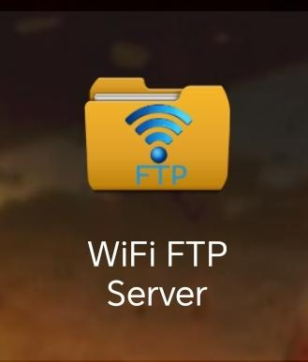

- Open the app
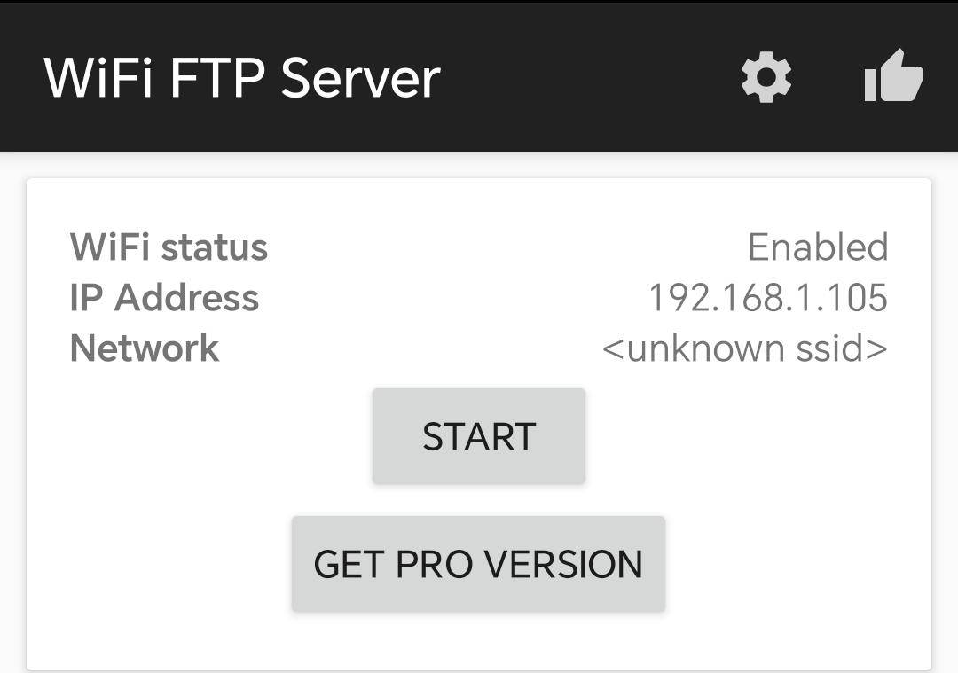

- Click on start
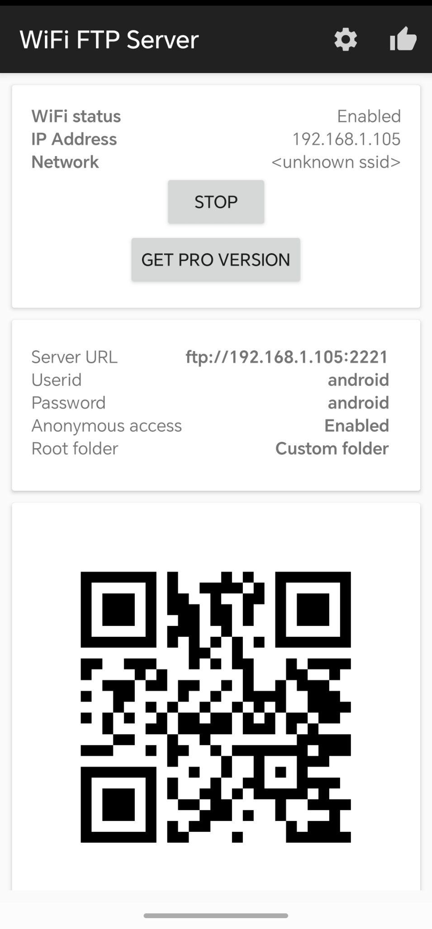

- Go to “This PC” in your laptop or computer
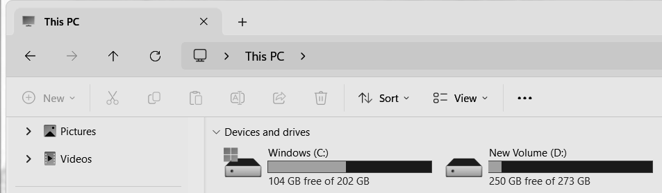

- Right click and click on “Add a network location”
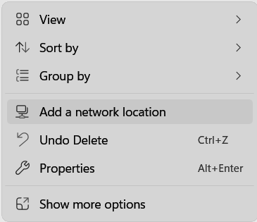

- Click “Next”
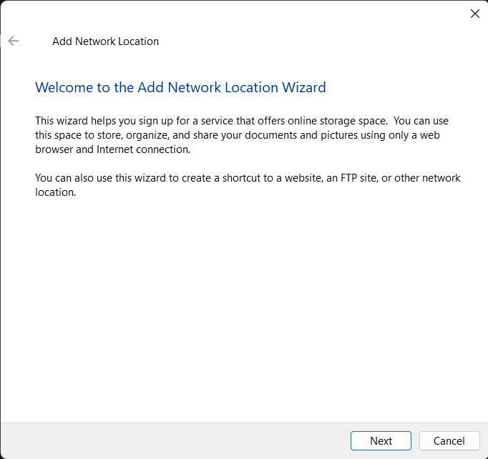

- Click on “Choose a custom network location”
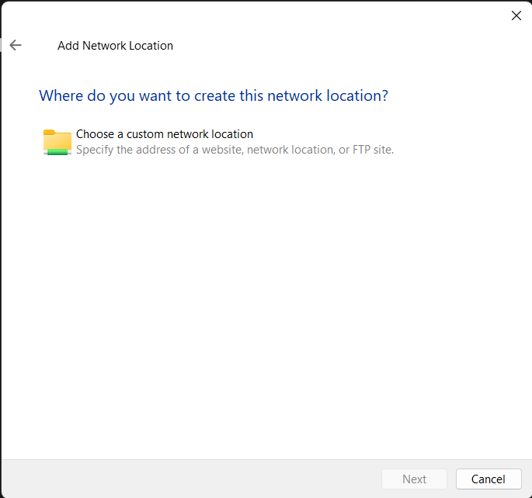

- Here we must type the IP address which is available in our phone and click on “Next”.
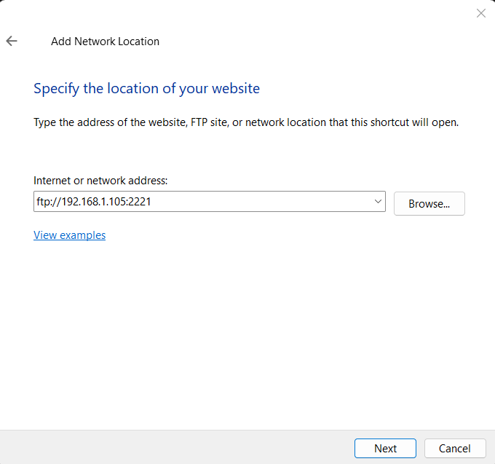

- Now we must enter the username which is also available on our phone
and click on “Next”

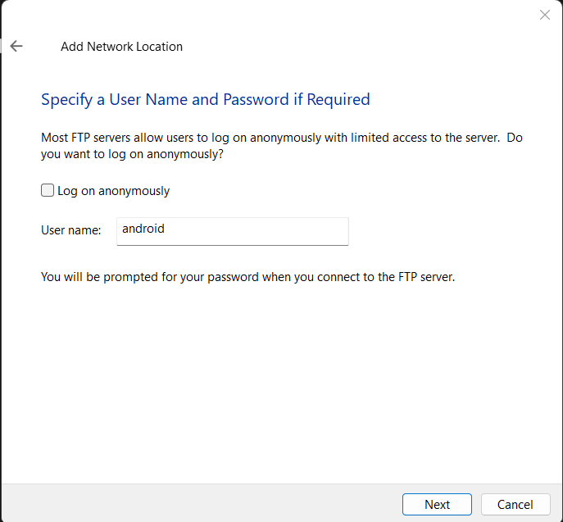

- Now we must give this network a name for easy identification and click on “Next”.
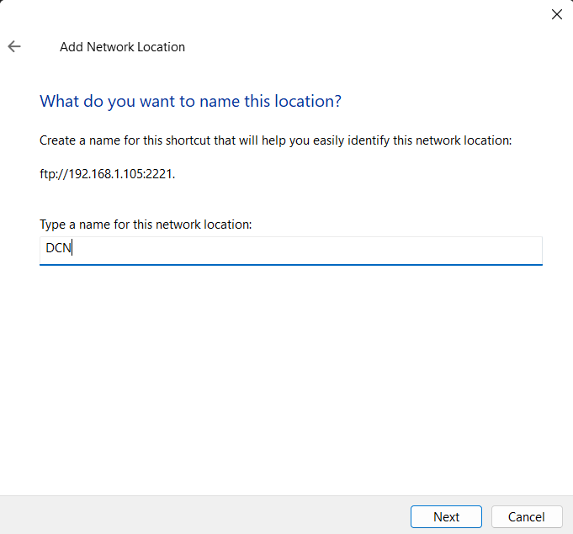

- Now we must click on “Finish”
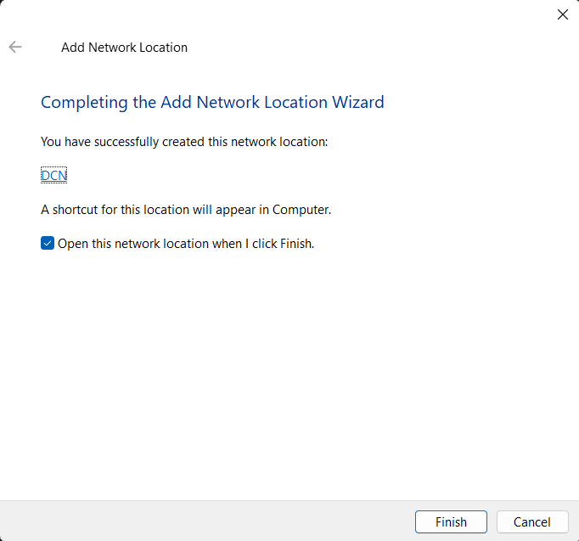

- Now we are able to access all the data available on our mobile.
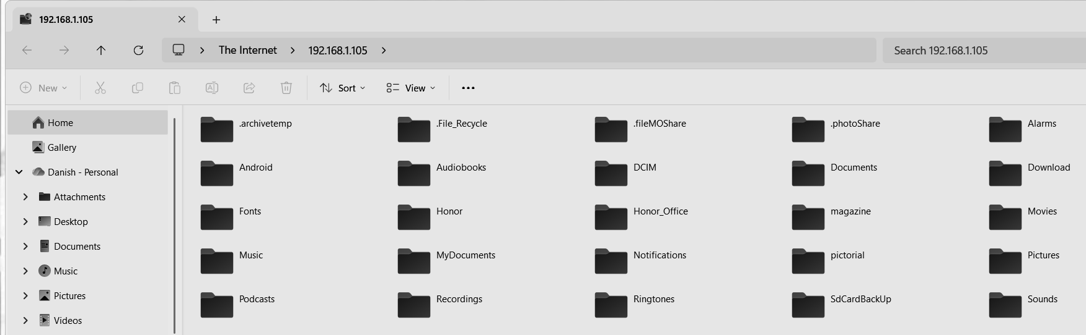

- Our Network location was added successfully.
